**Power BI Desktop Screenshot:**

**Report View:**

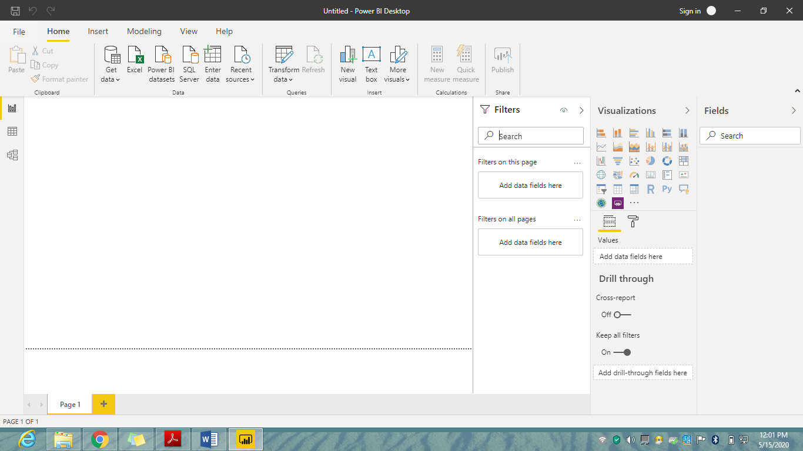

**Data View:**

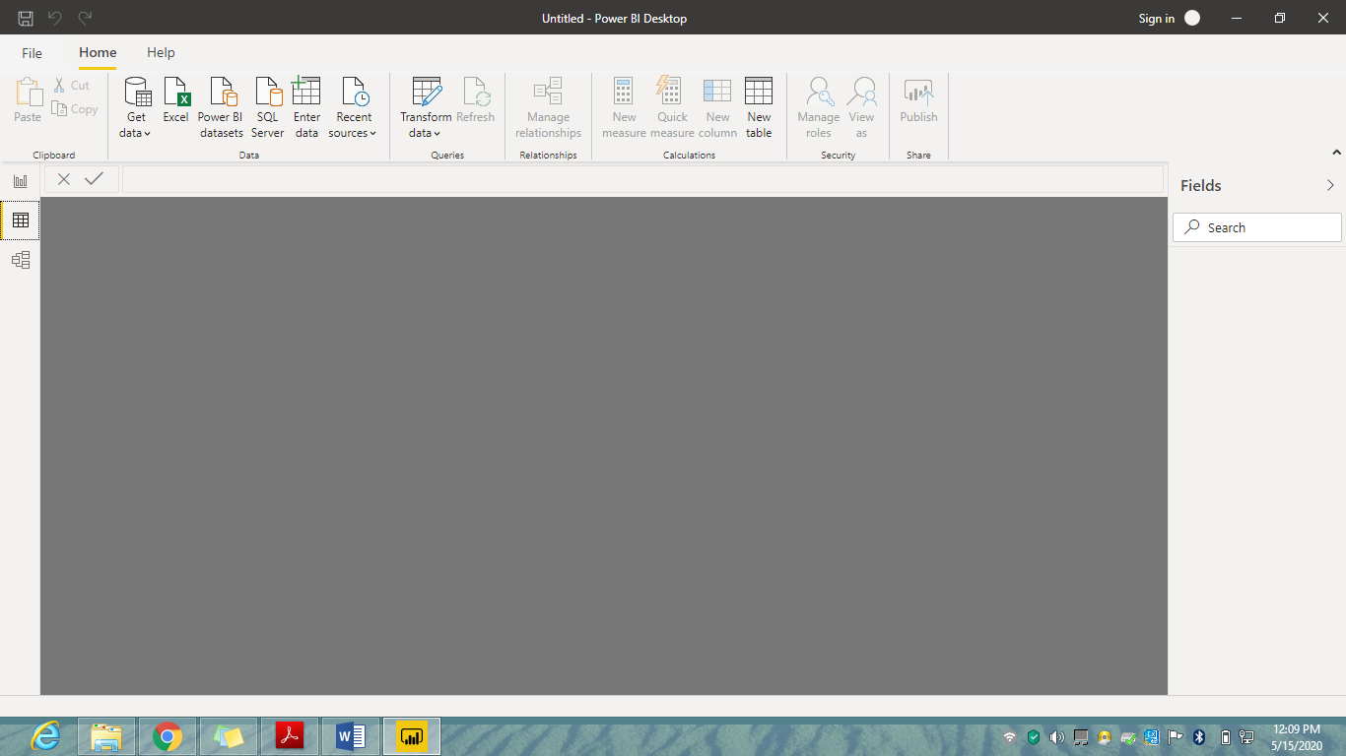

**Model View:**

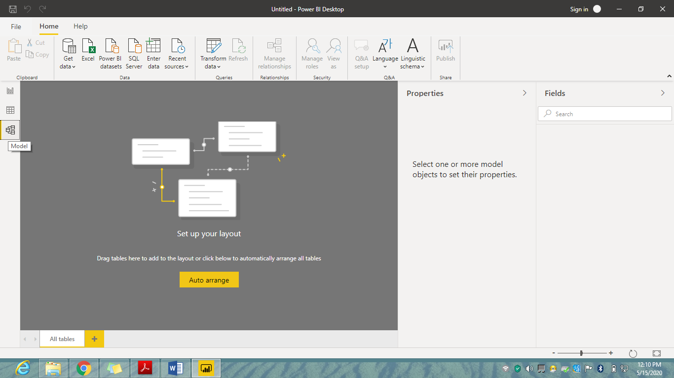

**Power Query Editor:**

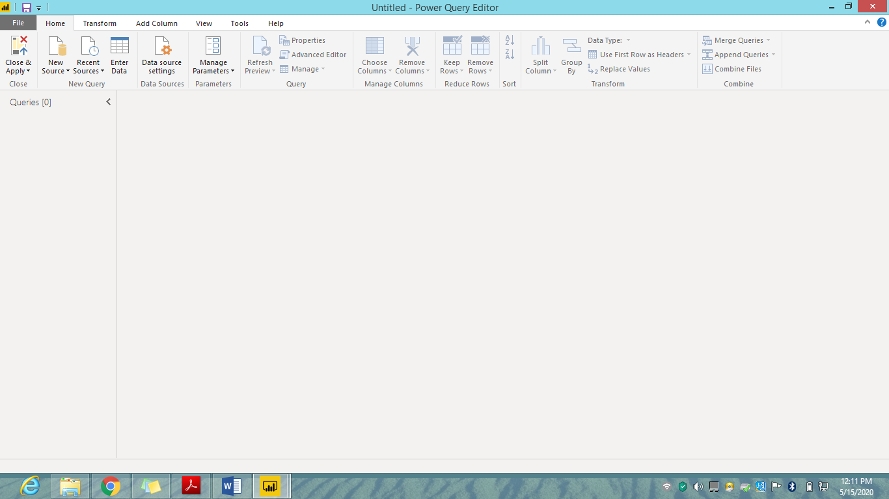

**Advance Editor:**

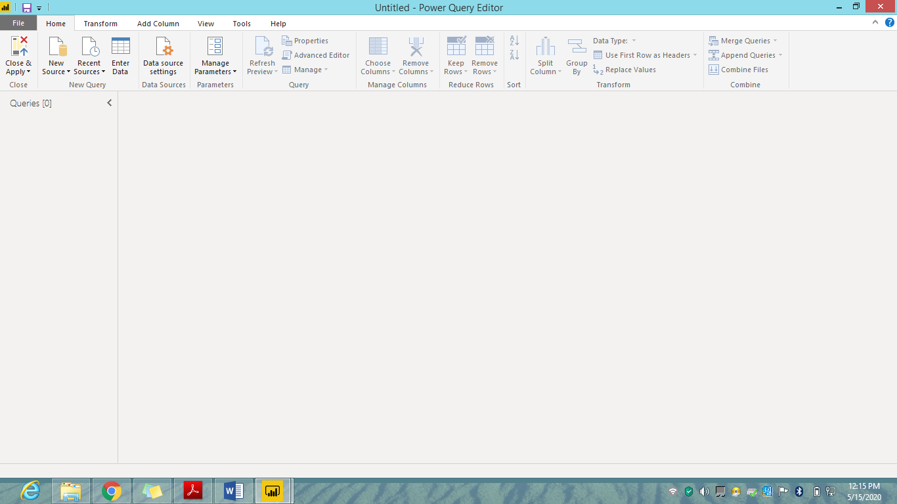

**Power BI Desktop, Pro, Premium:**

